Github documentation

Made by: Pedro Torrijos, Ignacio Donderis and Miguel Santiago

Index

Prepare anaconda

Create the folder and open with VS code Git clone

Close the remote connection Git init command Github repository

Git remote add repository url Git add

Commit and ﬁnally the push Clean of the data Server SQl and PBI

* We **prepare anaconda** for the entire process.

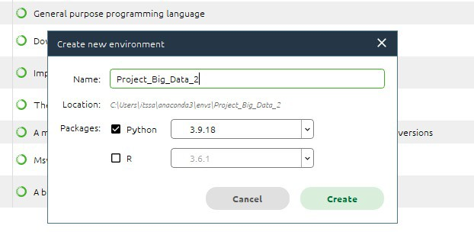

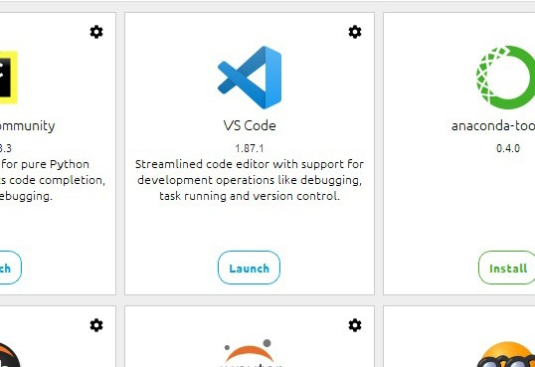

* We **create the folder** where we are going to host the git repository locally and **open with VS code.**

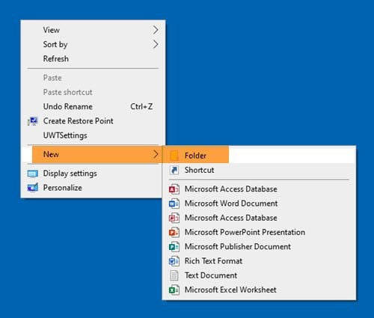 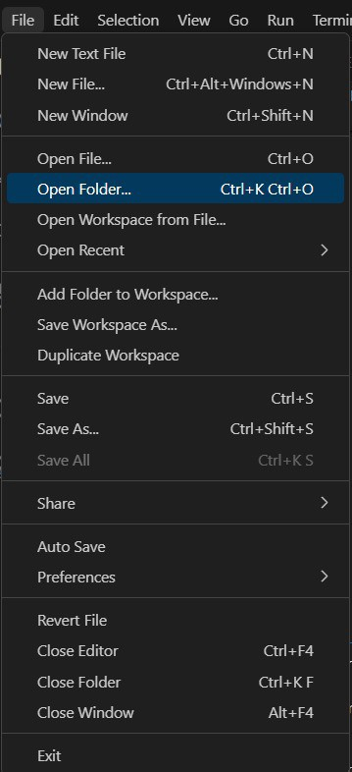

* First of all you cloned a repository with the **git clone** command.

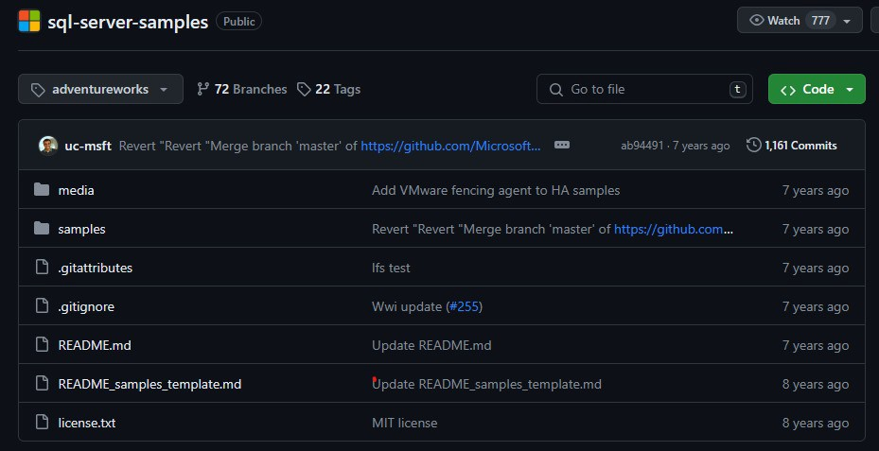

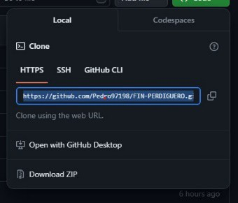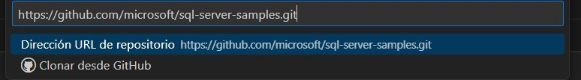

* We **close the remote connection** with the git-hub repository.

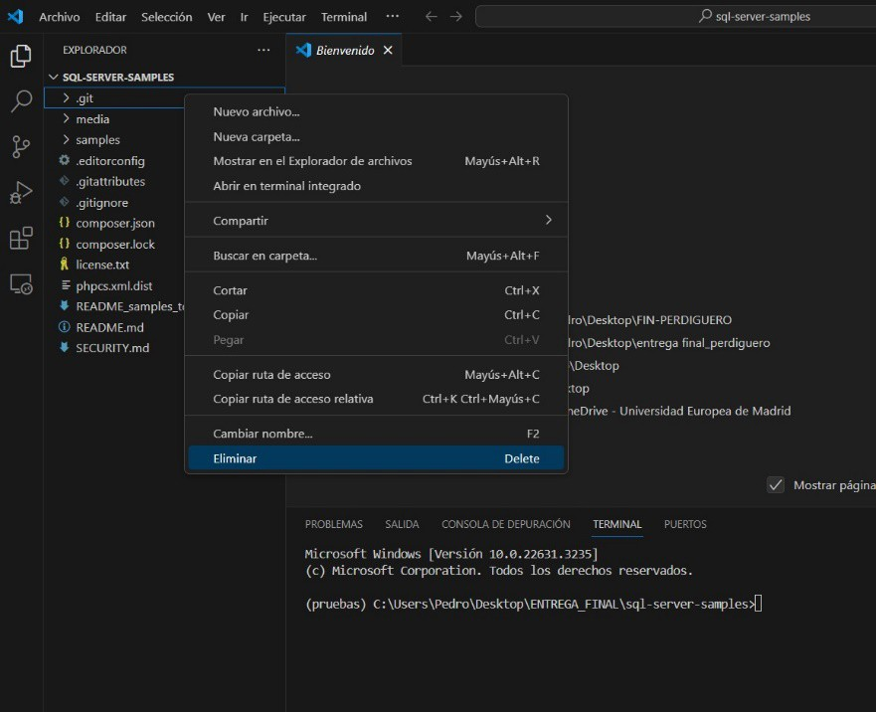

* We execute the **git init command**.



* We **created a github repository**.
* We execute the command **git remote add repository url**.



* We do a **git add**.



* We do the **commit and ﬁnally the push**.



* **Clean** of the data: We proceed to eliminate the items and folders that we are not going to use, and understand the rest of the data.
* We've recently set up an SQL server to manage our data, and as part of this process, we've incorporated the AdventureWorks database. This involved placing the AdventureWorks .bak ﬁle inside our local SQL server for easy access and management.

With the SQL server up and running, we seamlessly connected it to Power BI, leveraging its powerful data visualization capabilities. Using Power BI, we imported all the data from AdventureWorks, allowing us to delve deep into its insights and metrics.

After importing the data, we took it a step further by creating an entity-relationship diagram. This diagram visually represents the relationships between different entities (such as tables) in the AdventureWorks database. It's a crucial step in understanding the data model and how various pieces of information are connected.

